**Title: The Impact of Artificial Intelligence and Robotics on Higher Education**

**Research paper –** <https://rdcu.be/dzewE>

{ Exploring the impact of Artificial Intelligence and robots on higher education through literature-based design fictions }

Published in Springer

**Introduction:**

The potential impact of Artificial Intelligence (AI) and robots on higher education (HE) is a subject of considerable interest but remains complex and multifaceted. Currently, literature on the topic is fragmented, with separate discussions surrounding AI for education, learning analytics, and educational data mining. Moreover, AI is not a singular technology but an evolving concept, making its implications for HE difficult to fully grasp. While some applications of AI and robotics in HE are already mature, others are just beginning to be imagined, creating a temporal mix of past, present, and future impacts.

Understanding the holistic implications of AI and robots in HE is crucial due to the range of challenges they pose, including pedagogic, practical, ethical, and social justice considerations. The introduction of these technologies into educational settings is expected to encounter hurdles, as seen in past technological adoptions. Critiques in the educational literature often focus on concerns about dehumanizing the learning experience and the commercialization of education.

**Domain**

The domain of this study is higher education, encompassing universities, colleges, and research institutions. It focuses on how AI and robotics are reshaping teaching methodologies, research processes, and administrative functions in the HE sector. In classrooms and training centers, AI-powered adaptive learning tailors educational content to each student's needs, while plagiarism detection ensures academic integrity. Teachers and trainers can even leverage data analytics to predict student performance so they can intervene early if they spot problems.

AI has also played a significant role in democratizing access to education, especially for those in remote or underprivileged areas. AI-driven language translation tools and real-time transcription services have broken down language barriers, enabling students worldwide to access educational content from anywhere in the world. AI-powered virtual tutors can provide one-on-one support and guidance, supplementing traditional classroom instruction and making quality education accessible to a broader audience.

**Summary**

The review encompasses both AI and robotics, across various functions of HE, including teaching, research, administrative functions, and smart campus initiatives. Systematic searches combined with snowballing techniques were employed to gather relevant literature, focusing on recent applications and trends in AI and robotics, as well as their social implications. The review aims to provide a holistic view of the potential impacts of AI and robots on HE, laying the groundwork for the development of design fictions that instantiate these issues in a fictional form.

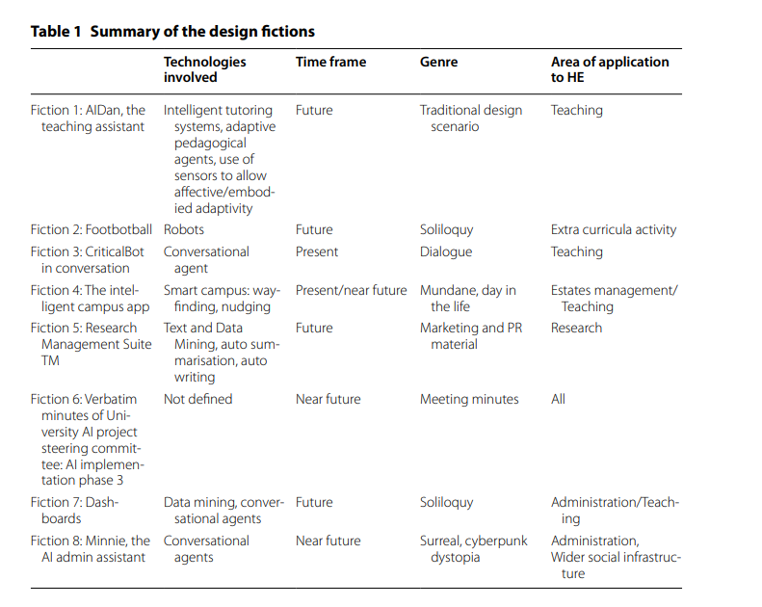

**Problem Identified**

The literature on AI in learning predominantly focuses on various types of systems designed to directly engage and support students' learning processes. These include Intelligent Tutoring Systems (ITS), Automatic Writing Evaluation (AWE) tools, Conversational Agents (Chatbots or virtual assistants), and Adaptive Pedagogical Agents. These technologies aim to personalize learning experiences, provide feedback, and facilitate interaction between learners and educational content. While some of these technologies, such as AWE and ITS, are relatively mature, there is a wide range of different systems within each category, each with its own capabilities and potential applications.

However, much of the literature primarily discusses the development and evaluation of these AI technologies from a technical standpoint, often neglecting pedagogical and ethical considerations. Some authors, like Luckin and Holmes, advocate for a broader perspective, envisioning how AI can address broader challenges in education, such as personalization, continuous monitoring of performance, and the development of 21st-century skills.

To illustrate this vision, a fictional narrative, inspired by their work, envisions an educational setting where AI plays a central role in supporting teaching and learning. In this narrative, AI serves as a teaching assistant, personalized learning experiences are continuously monitored and adjusted based on individual performance and emotional states, and students develop long-term relationships with AI companions. The narrative also highlights the potential benefits of AI in supporting lifelong learning and personalized services across various aspects of university life.

However, the narrative also acknowledges potential concerns, such as the implications of continuous monitoring for surveillance and the ethical implications of personalizing learning experiences through AI. This fictional scenario offers a glimpse into a possible future where AI transforms education but also raises questions about its broader societal implications and ethical considerations.

**Agent studied and Algorithm or Search Techniques Used:**

1] ITS

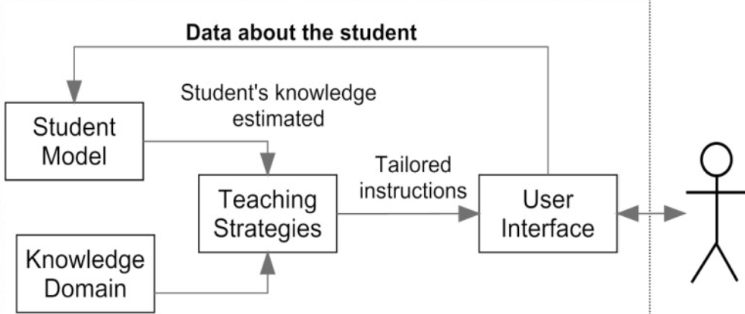

As its name suggests, an AI intelligent tutoring system is a computer-based learning system that uses artificial intelligence to provide human-like lessons without a human teacher.AI intelligent tutoring systems allow you to create a personalised learning experience that provides immediate instruction and feedback to learners, usually without human intervention.

Intelligent Tutoring Systems (ITS) utilize various AI-based technologies across different components to create personalized and adaptive learning experiences. Let's delve into each component and explore the AI-based technologies commonly used:

1. User Interface (UI):

1. Natural Language Processing (NLP): NLP enables ITS to understand, interpret, and generate human language. Techniques include:

a)Text Tokenization: Breaking down text into smaller units (tokens), such as words or sentences.

b)Part-of-Speech Tagging: Assigning grammatical tags (noun, verb, adjective, etc.) to each word in a sentence.

c)Named Entity Recognition (NER): Identifying and classifying named entities (e.g., people, organizations, locations) in text.

1. Speech Recognition: This technology converts spoken language into text, allowing users to interact with the ITS through voice commands. Techniques include:
   1. Acoustic Modelling: Modelling the acoustic characteristics of speech sounds to identify phonemes and words.
   2. Language Modelling: Predicting the sequence of words in a spoken utterance based on statistical language models.
2. Gesture Recognition: Gesture recognition systems interpret hand movements, gestures, or body poses made by users. Techniques include:
   1. Depth Sensing: Using depth-sensing cameras (e.g., Microsoft Kinect) to capture 3D information about the user's gestures.
   2. Feature Extraction: Extracting relevant features from the captured gestures (e.g., hand shape, movement trajectory).
   3. Eye Tracking: Eye tracking technology monitors and analyzes the movements and fixations of the user's eyes. Techniques include:
   4. Corneal Reflection: Using infrared light to illuminate the eyes and track the reflections from the cornea.
   5. Pupil Centre Corneal Reflection (PCCR): Calculating the gaze direction based on the position of the pupil and corneal reflection.

2. Teaching Strategies:

1. Machine Learning Algorithms: Various machine learning algorithms are employed to develop adaptive teaching strategies. These include:
   1. Decision Trees: Hierarchical models that make decisions based on the features of the input data.
   2. Neural Networks: Deep learning models composed of interconnected layers of artificial neurons that learn complex patterns.
   3. Reinforcement Learning: Learning through trial and error, where the system receives feedback (rewards or penalties) based on its actions.
2. Expert Systems: Expert systems utilize knowledge representation and inference mechanisms to emulate the decision-making of domain experts. Techniques include:
   1. Rule-Based Systems: Systems that use a set of rules (if-then statements) to make decisions or provide recommendations.
   2. Inference Engines: Engines that apply logical reasoning to derive new information from existing knowledge.
3. Adaptive Algorithms: These algorithms dynamically adjust teaching strategies based on real-time feedback and student performance. Techniques include:
   1. Adaptive Sequencing: Modifying the sequence of learning activities or content based on the student's progress and preferences.
   2. Adaptive Feedback: Tailoring feedback messages to address the specific needs and misconceptions of individual students.

3. Knowledge Domain:

1. Knowledge Representation: Techniques for representing and organizing domain-specific knowledge include:
   1. Semantic Networks: Graph-based structures representing concepts and their relationships.
   2. Ontologies: Formal representations of domain knowledge, specifying concepts, properties, and relationships.
2. Semantic Web Technologies: These technologies facilitate the integration and interoperability of educational resources, including:
   1. Resource Description Framework (RDF): A framework for describing and linking resources on the web.
   2. Web Ontology Language (OWL): A language for defining ontologies and specifying relationships between concepts.
3. Domain-Specific Reasoning Engines: Reasoning engines apply domain-specific rules and heuristics to infer new knowledge or solve problems. Techniques include:
   1. Forward Chaining: Starting with known facts and using rules to derive new conclusions.
   2. Backward Chaining: Starting with a goal and working backward to determine the conditions necessary to achieve it.

4. Student Model:

1. Data Mining and Learning Analytics: Techniques for analysing student data and building predictive models include:
   1. Classification: Predicting discrete class labels (e.g., pass/fail) based on input features.
   2. Clustering: Grouping students into clusters based on similarities in their learning behaviours.
2. Bayesian Networks: Bayesian networks model the probabilistic relationships between variables in the student's learning environment. Techniques include:
   1. Parameter Learning: Estimating the parameters (probabilities) of the network based on observed data.
   2. Inference: Using the network to make probabilistic predictions or decisions about new data.
3. Cognitive Modelling: Techniques for simulating cognitive processes include:
   1. Production Systems: Representing cognitive processes as a set of production rules (if-then statements).
   2. ACT-R (Adaptive Control of Thought—Rational): A cognitive architecture that models human cognition using symbolic and procedural representations.

By leveraging these AI-based technologies, Intelligent Tutoring Systems can provide personalized, adaptive, and effective learning experiences tailored to the needs and preferences of individual learners.

Future Work:

Future research in this area may include further exploration of the ethical considerations surrounding AI and robotics in HE, the development of guidelines for responsible implementation, and the investigation of long-term societal impacts. Additionally, ongoing analysis of emerging trends and advancements in AI and robotics will be crucial for informing future strategies and practices in the higher education sector. Future work may also involve the development of innovative tools to support academic productivity, the exploration of new teaching methodologies, and the enhancement of student learning experiences through AI and robotics integration.